12th ANKARA INTERNATIONAL AEROSPACE CONFERENCE AIAC-2023-000
13-15 September 2025 – Onlne, Ankara TURKIYE

THE TITLE OF THE PAPER SHOULD BE CENTERED IN SIZE 12 BOLD CAPITAL LETTERS
Name1 LastName1 and Name2 LastName2  A University  City, Country | Name3 LastName3  A Company  City, Country

ABSTRACT
One paragraph abstract of about 100 words summarizing the content of the paper should be included at the beginning of the paper. It should state the objectives of the study and conclusions briefly.

INTRODUCTION
Major Headings should be placed centered in uppercase bold letters.
Subheadings
Subheadings should be placed flush left of the page on a separate line in bold upper and lowercase letters.
Sub-subheadings: should be underlined and placed flush left of the page in upper and lowercase letters.

METHOD
Figures (Figure 1) should be embedded into the page it is referred in rather that listed at the end of the paper. References should be cited in the author-year form in square parentheses [AuthorA, 2009]. The cited references [AuthorA, 2009; AuthorB and AuthorC, 2012] should be listed at the end of the paper in alphabetical order according to the surnames of the authors and editors.

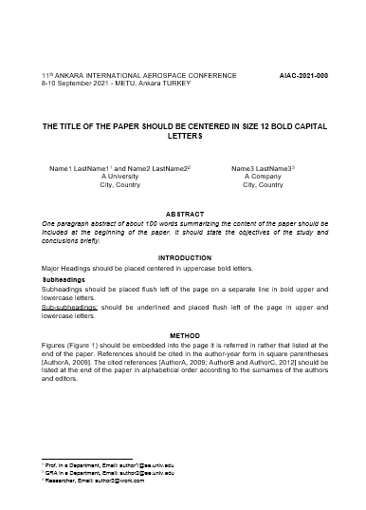

Figure 1: A sample page

References
AuthorA, D.(2009) Title of the Reference 1 …, Conference, Jan 2009
AuthorB, E. and AuthorC, F.M. (2014) Title of the Reference 2 …, Publisher, Vol. 1, p: 1-10, Jun 2014.

Prof. in a Department, Email: author1@ae.univ.edu
GRA in a Department, Email: author2@ae.univ.edu
Researcher, Email: author3@work.com

